# How to use Big Blue monitoring script

Step 1: Ensure you have the correct drivers installed for the Keyspan device.

* Link: <https://assets.tripplite.com/drivers/keyspan-driver-for-usa-19hs-win10-win11.zip>
* Unzip folder to desktop
* Make sure the Keyspan USB is physically connected to your PC.
* Press your Windows key and type “Device Manager”
* Once that opens, click the drop-down arrow on “Other Devices” You should see the Keyspan device on there.

* Now right click the Keyspan device and click “Update Driver”. Click “Browse for drivers manually” and select the folder where you extracted the zip file.

* Click through the prompts so that it installs the drivers.
* Now click the drop-down arrow on “Other Devices” You should now see “Unknown device” on there.

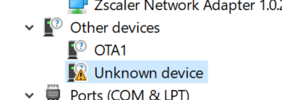

* Now right click the unknown device and click “Update Driver”. Click “Browse for drivers manually” and select the folder where you extracted the zip file.
* You can now delete the driver folder from your Desktop.

Step 2: Restart your PC (not always necessary, but should ensure that you don’t run into issues)

Step 3: Connect the USB to your PC, and the CAN adapter to the Big Blue port.

Step 4: Find the COM port that the Keyspan device is using.

* Press your Windows key and search for “Device Manager”
* Now click the drop down arrow on “Ports (COM & LPT)”
* You should see “Keyspan USB Serial Port (COMxx)”

* You will need that COM port for the next step.

Step 5: Setup Python for the Big Blue script.

* Go to this website: <https://www.python.org/downloads/release/python-3112/>
* Scroll down to “Files” at the bottom and click “Windows Installer (64-bit)”
* After downloading, open the file and go through the installer. Make sure to select the following options:

* After the installation is done, it will come up with the following screen. Click “Disable Path Length Limit”

* Press close on the installer, then press your Windows key and type “cmd” and press enter.
* Once your Command Prompt opens, type “python” and press enter to check that you are installed.

* Type “exit()” to get out of this python terminal.
* Now run the following command to install the needed Python dependencies:
  + pip install pyserial minimalmodbus



Step 6: Run the script

* In the Command Prompt, you need to navigate to the directory where the scripts are located.
* Do this by typing “cd” then the next directory you want to enter. For example, my terminal will look like this:

* If you need more information on how to use the CD command, check out this website: <https://www.geeksforgeeks.org/cd-cmd-command/>
* Once you are in the folder, type “python monitor_chamber.py COM21” with the COM port being the one you found on your machine earlier.
* The script will ask you for the interval you want to collect data, and the amount of time you want to collect data for. Enter these values and then the script will run.

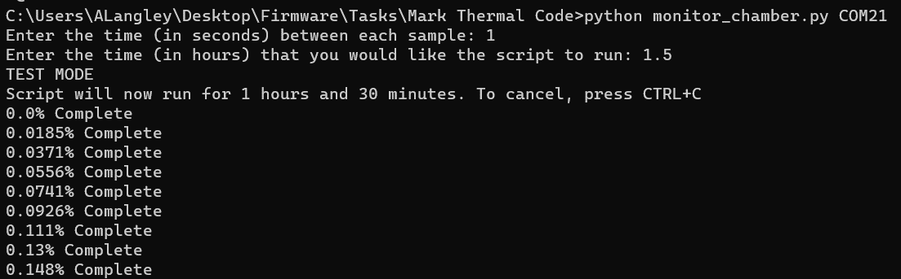

* The code should now run automatically, and will save data to a CSV after the given time.

Step 7: If you have any problems, ask Austin Langley for help. (Please don’t have problems though)